CHAPTER 12
Monopolistic Competition: The Competitive
Model in a More Realistic Setting
- Chapter Summary
- Learning Objectives
- Chapter Outline
Teaching Tips/Topics for Discussion
- Solved Problems
- Solutions to Review Questions and Problems and Applications

1. Chapter Summary
Most markets in the U.S. economy have many buyers and sellers, low entry barriers and differentiated goods and services for sale. These are monopolistically competitive markets. Each monopolistically competitive firm faces a downward-sloping demand curve, so marginal revenue is less than price. The profit-maximizing output occurs where marginal revenue equals marginal cost. The firm may earn an economic profit or suffer an economic loss in the short run. Since there are low entry barriers, economic profits will cause new firms to enter the market. A firm that earns short-run profit will earn zero economic profit in the long run as entry from new firms shifts the firm’s demand curve to the left and causes it to become more elastic. If a firm suffers economic loss in the short run, other firms will exit the market and shift the firm’s demand curve to the right and cause it to become less elastic. In the long run, the firm’s demand curve will be tangent to its long-run average total cost curve, but average total cost will be greater than its minimum level.
Monopolistic competition and perfect competition differ in their long-run equilibrium positions: monopolistically competitive firms charge a price greater than marginal cost and they do not produce at minimum average total cost. A monopolistically competitive firm has excess capacity: if it increased its output, it could produce at lower average cost. Monopolistically competitive markets are not productively or allocatively efficient. But consumers benefit from being able to purchase a product that is differentiated and more closely suited to their tastes.
Firms can use marketing to differentiate their products. Marketing tools include brand management and advertising.

2. Learning Objectives
Students should be able to:
- Explain why a monopolistically competitive firm has a downward-sloping demand curve.
- Explain how a monopolistically competitive firm decides the quantity to produce and the price to charge.
- Analyze the situation of a monopolistically competitive firm in the long run.
- Compare the efficiency of monopolistic competition and perfect competition.
- Define marketing and explain how firms use it to differentiate their products.
- Identify the key factors that determine a firm’s profitability.

3. Chapter Outline
Starbucks: Growth through Product Differentiation
1. Since the first Starbucks coffee shop opened in 1971, the firm has grown into a worldwide company. But the growth has been in the number of shops, over 8,000, rather than the size of the shops themselves. Starbucks faces competition from other firms; neighborhoods often have three or more coffeehouses. Barriers to entry into the market for coffeehouses are low and firms differentiate their products by offering different menus and services.
►Teaching tips: An Inside Look at the end of this chapter features a newspaper story about some restaurants extending their business hours. This represents another way for firms to differentiate their product. You may assign both of these readings and use the Thinking Critically questions at the end of An Inside Look and the related Problems and Applications # 22 for discussion or evaluation.
Demand and Marginal Revenue for a Firm in a Monopolistically Competitive Market
1. Monopolistic competition is a market structure in which barriers to entry are low, and many firms compete by selling similar, but not identical products.
- Product differentiation allows monopolistically competitive firms to raise their prices without losing all of their customers.
- The control monopolistically competitive firms have over their prices is limited because they face competition from firms selling similar products.
- Since firms have downward-sloping demand curves, marginal revenue is less than price.
►Teaching tips: There are many examples of monopolistically competitive markets that students will be familiar with: restaurants, convenience stores, bookstores, etc. A good example to use in the classroom is gas stations. Prices are prominently displayed so that differences between stations can easily be seen. Students will understand why price differences for two stations located on opposite sides of the street will be slight. Ask students for reasons why they buy from a certain station. One possible response, especially for stations located on busy highways: “I buy from a station on my right side so I don’t have to make two left turns.” They will understand why someone would pay a slightly higher price for this convenience.
How a Monopolistically Competitive Firm Maximizes Profits in the Short Run
1. As with firms in other markets, a monopolistically competitive firm will produce the level of output where marginal revenue (MR) is equal to marginal cost (MC) to maximize its profits.
- Because the MR curve lies below the firm’s demand curve, the firm will maximize profits where price (P) > MC.
- Profit = (P – ATC) x Q
►Teaching tips: The table and graph in Figure 12-4 provide an example of a firm that makes a short-run profit. Remind students that (a) the relevant values for MR, MC and ATC are determined at the profit-maximizing quantity, or where MR = MC, and (b) when firms earn profits the ATC curve crosses the demand curve at two points. Assign Solved Problem 12-1 to help students understand the importance of marginal cost, and the unimportance of fixed costs, in the determination of the equilibrium quantity.
What Happens to Profits in the Long Run?
1. Short-run profits give entrepreneurs an incentive to enter a market and establish new firms.
- The demand curve of an established firm shifts to the left and becomes more elastic as new firms enter the market. Entry will continue until the firm’s demand curve is tangent to its ATC curve.
- In the long run:
  - P = ATC and the firm breaks even (zero economic profit).
  - The firm’s demand curve is more elastic.
2. Short-run losses mean firms will exit their market. As a result:
- The demand curve for a firm remaining in the market shifts to the right and becomes less elastic.
- Exit continues until the representative firm can charge a price equal to ATC.
3. Firms must find new ways to differentiate their products to earn short-run profits.
►Teaching tips: This section contains several features to help students understand the transition of the market from short-run to long-run equilibrium. Don’t Let This Happen to You! reminds students not to confuse economic and accounting profit. Graphs in Figure 12-5 illustrate the short-run for a firm earning profits and how these profits are eliminated in the long run firm. Table 12-2 offers a comprehensive graphical summary of short run and long run for a monopolistically competitive firm. Other features: Making the Connection 12-1 and Solved Problem 12-2 use the experience of Apple Computers to analyze the short run and long run under monopolistic competition; Making the Connection 12-2 describes the effort of a cosmetics company to stay ahead of its competition.
Comparing Perfect Competition and Monopolistic Competition
1. There are two important differences between long-run equilibrium perfect competition (PC) and monopolistic competition (MO).
- MO firms charge a price > MC.
- MO firms do not produce at minimum ATC.
- Since price > MC, allocative efficiency is not achieved.
- Since price > minimum ATC, productive efficiency is not achieved. MO firms have excess capacity.
2. Although consumers pay a price > MC under MO and the product is not being produced at minimum ATC, they benefit from being able to purchase products that are differentiated.
►Teaching tips: Although monopolistic competition appears to fall short of perfect competition in terms of economic efficiency, the textbook rightly notes that consumers are willing to pay for the variety offered by monopolistically competitive firms. Here is an example you can give to your students: let’s say there are three gas stations on a single street corner. During most hours of the day, at least one or two of the stations is not busy; one can interpret this as excess capacity. But during rush hours, all three stations have customers. Enough drivers are willing to pay to keep all three stations operating for the convenience of not waiting in long lines during peak hours. Another example of consumers’ willingness to pay for greater convenience: most supermarkets open additional check-out lines – some for consumers with just a few items to buy – when long lines start to form.
How Marketing Differentiates Products
1. Firms can differentiate their products through marketing. Marketing refers to all the activities necessary for a firm to sell a product to a consumer.
2. Firms use two marketing tools to differentiate their products:
- Brand management refers to the actions of a firm intended to maintain the differentiation of a product over time.
- Economic profits are earned when a firm introduces a new product, but this invites entry of firms that eliminates the profits.
- Firms use brand management to put off the time when they will no longer be able to earn profits.
- Advertising
- Advertising shifts the demand curve for a product to the right and makes it more inelastic.
- Successful advertising allows the firm to sell more at every price.
- Advertising increases cost. If the increase in revenue from advertising exceeds the cost, profit will rise.
3. Once a firm has established a brand name, it has an incentive to defend it.
- Firms can apply for a trademark.
- A trademark grants legal protection against other firms using a product’s name.
- Companies will spend substantial amounts of money to ensure that their brand names are entitled to legal protection.
- If its trademarked name becomes widely used for a type of product, the firm may no longer be entitled to legal protection from unauthorized use of that trademarked name.
►Teaching tips: See Solved Problem 12-5 for an example of the legal means 3Com Corporation uses to protect its trademarks.
What Makes a Firm Successful?
1. A firm can control some of the factors that allow it to make economic profits. Other factors are uncontrollable.
- Controllable factors include:
- The ability a firm has to differentiate its product.
- The ability to produce at a lower average total cost than competing firms.
- Uncontrollable factors include:
- Prices of inputs.
- Changes in consumer tastes.
- Chance events.
►Teaching tips: See Solved Problem 12-6 for examples of controllable and uncontrollable factors.

4. Solved Problems
Chapter 12 in the textbook includes two Solved Problems to support Learning Objectives 2 (Explain how a monopolistically competitive firm decides the quantity to produce and the price to charge) and 3 (Analyze the situation of a monopolistically competitive firm in the long run). The following Solved Problems support this chapter’s four other learning objectives.

Solved Problem 12-3 Supports Learning Objective 1: Explain why a monopolistically competitive firm has a downward-sloping demand curve.

For all you do, this Fat Tire’s for you!
Between 1950 and 1980, consolidation and bankruptcy dramatically reduced the number of breweries in the United States. The largest of the survivors, Anheuser-Busch and the Miller, Coors and Pabst Brewing companies, dominated the market and their flagship brands became household names. But beginning in the 1980s a number of new breweries began to produce and sell small quantities of beer. These “microbreweries” grew in popularity among aging baby boomers and young adults who thirsted for a greater variety of flavors and brands – and didn’t mind paying more for them. Popular new lagers, stouts, pilsners, and ales were often sold in brewpubs, or bars attached to the microbreweries. By 2004, of the 1,430 breweries in the United States, 1,396 were regional small craft breweries (this term includes regional specialty breweries, microbreweries, and brewpubs). The relative size of these firms is evident in their small share of the national market – 3.2 percent in 2004 – versus 85.2 percent for the larger traditional breweries. Imported beers make up the rest of the market.

Though unknown in other parts of the country, new brand names such as Fat Tire (New Belgium Brewing Co., Fort Collins, CO), Hefe-Weizen (Widmer Brothers Brewing Co., Portland, OR) and India Pale Ale (Harpoon Brewery, Boston, MA) have become regional favorites.

Sources: Top 50 American Breweries Reflect the Diversity of American Beer, March 14, 2005. 2004 Craft Brewing Industries Statistics, April 22, 2005. Brewers Association, www.beertown.org.

  - Explain the significance of a downward-sloping demand curve for a firm.
  - Use a microbrewery as an example of a monopolistically competitive firm that has a downward-sloping demand curve.

Solving the Problem:
Step 1: Review the chapter material. This problem is about the demand curve of a monopolistically competitive firm, so you may want to review the material in the section Demand and Marginal Revenue for a Firm in a Monopolistically Competitive Firm, which begins on page 388 in the textbook.
Step 2: Explain the significance of a downward-sloping demand curve for a firm. A perfectly competitive firm faces a perfectly elastic, or horizontal, demand curve. This means that the firm has no control over price. A firm with a downward-sloping demand curve has some control over the price it charges; the firm can raise price without quantity demanded falling to zero.
Step 3: Use a microbrewery as an example of a monopolistically competitive firm that has a downward-sloping demand curve. A microbrewery is a small firm that operates in a local or regional market. The owner or manager of a microbrewery can set the price of his product above the price of other beers if his customers believe the price is worth paying for superior quality or variety. However, many substitutes exist for this product; if price is set too high, customers can and will buy other lower-priced or better-tasting beers.

Solved Problem 12-4 Supports Learning Objective 4: Compare the efficiency of monopolistic competition and perfect competition.

Variety: The Spice of Life?
In its 1998 Annual Report, the Federal Reserve Bank of Dallas commented on the growing variety of choices available to consumers:
Just since the 1970s, there’s been an explosion of choice in the marketplace – the assortment of new [automobile] models has risen from 140 to 260, soft drinks from 20 to more than 87…over-the-counter pain relievers from 17 to 141. The U.S. market offers 7,563 prescription drugs, 3,000 beers, 1,174 amusement parks, 340 kinds of breakfast cereal, 50 brands of bottled water…Today’s consumers have access to more book titles, more movies and more magazines…
This proliferation of products, models and styles isn’t capitalism run amok. Variety shouldn’t be dismissed as extravagance. It’s a wealthy, sophisticated society’s way of improving the lot of consumers. The more choices, the better. A wide selection of goods and services increases the chance each of us will find, somewhere among all the shelves and showrooms, products that meet our requirements.

Source: W. Michael Cox and Richard Alm, “The Right Stuff: America’s Move to Mass Customization.” Federal Reserve Bank of Dallas 1998 Annual Report pages 3-5. www.dallasfed.org

  - Compare the long-run equilibrium positions of firms in perfect competition and monopolistic competition.
  - Evaluate the efficiency of producing products in monopolistically competitive markets rather than perfectly competitive markets.

Solving the Problem:
Step 1: Review the chapter material. Since this problem compares perfect competition and monopolistic competition, you may want to review the section Comparing Perfect Competition and Monopolistic Competition that begins on page 399 of the textbook.
Step 2: Compare the long-run equilibrium positions of firms in perfect competition and monopolistic competition.
Perfect Monopolistic
Competition Competition
Firms charge a price: Equal to marginal cost Greater than marginal cost
Equal to average total cost Equal to average total cost
Equal to minimum average total cost Greater than minimum average total cost

Allocative efficiency Is achieved Is not achieved (price > marginal cost)
Productive efficiency Is achieved Is not achieved (excess capacity)

Step 3: Evaluate the efficiency of producing products in monopolistically competitive markets rather than perfectly competitive markets. Although monopolistically competitive firms do not achieve allocative or productive efficiency, these firms achieve success in the marketplace by offering consumers products that better match their tastes than the standardized products that would be offered by perfectly competitive firms.

Solved Problem 12-5 Supports Learning Objective 5: Define marketing and explain how firms use it to differentiate their products.

We Came. We Marketed. We Sold.
3Com Corporation was mentioned in the introduction to the first chapter of the textbook. The firm was incorporated in 1979 and specializes in providing computer network devices such as routers and network switches. Among 3Com’s clients are businesses that want to improve the communication and security capabilities of their computer systems. 3Com is not a household name in the manner of McDonald’s or Microsoft, but marketing is an important part of the company’s success. It faces stiff competition from other computer service providers, such as Cisco Systems, and uses advertising and trademarks to influence its customers. 3Com’s advertising efforts are aimed primarily at computer network managers; for example, an advertising agency developed a two-page ad for 3Com titled “We Came. We Saw. We Routed.” Ads such as these are placed in publications most likely to be seen by the target audience. It would be less effective for 3Com to place ads in People or Time magazines, since few of their readers are computer network managers, than it would be to advertise in business publications. The importance of establishing and maintaining 3Com’s trademarks is indicated by the guidelines the firm’s legal experts issue to employees. The following is a small sample of these guidelines for over 40 company and product trademarks:

Always Use a Trademark as an Adjective, Followed by the Appropriate Description(s)
If not, the trademark could become generic…make sure that 3Com and the ® symbol (3Com®) precedes a trademark mention of the product or service.

Correct: The 3Com® NBX® business telephone has powerful call processing features.
Incorrect: NBX® has powerful call-processing features.
Sources: http://www.3com/corpinfo/en_US/legal/trademark/tmn_list.html
http://www.langstaffcommunications.com/Portfolio/Advertising/advertising/html

  - Define marketing and explain the importance of marketing to firms.
  - Explain how 3Com Corporation used marketing to differentiate its products.

Solving the Problem:
Step 1: Review the chapter material. Since this refers to the material in How Marketing Differentiates Products, you may want to review this section of the textbook, which begins on page 401.
Step 2: Define marketing and explain the importance of marketing to firms. Marketing refers to all the activities necessary for a firm to sell a product to a consumer. To earn profits, monopolistically competitive firms must differentiate their products. These firms use two marketing tools to do this: brand management and advertising.
Step 3: Explain how 3Com Corporation uses marketing to differentiate its products. 3Com Corporation uses brand management, including extensive use of trademarks and advertising, to differentiate its products. 3Com Corporation focuses its marketing strategies on its customers; for example, computer network managers.

Solved Problem 12-6 Supports Learning Objective 6: Identify the key factors that determine a firm’s profitability.

Factors Affecting the Success of Microbreweries and 3Com Corporation
A firm’s owners and managers can control some of the factors that can enable them to earn economic profits. Some of these factors are outside of the firm’s control.

List some of the controllable and uncontrollable factors of the firms mentioned in Solved Problems 12-3 (microbreweries and brewpubs) and 12-5 (3Com Corporation).

Solving the Problem:
Step 1: Review the chapter material. Since this problem refers to the factors that determine a firm’s profitability, you may want to read the section What Makes a Firm Successful? beginning on page 403 of the textbook.
Step 2: Controllable factors.
Controllable factors for the firms include: (1) The ability to differentiate their products. Examples: microbreweries – the types of beer brewed and the ingredients used to brew them; 3Com – the use of advertising targeted at computer network managers and trademarks. (2) Price – product differentiation allows microbreweries and 3Com to have some control over their prices but competition from rival firms limits this control.
Step 3: Uncontrollable factors. Uncontrollable factors include: (1) Prices of inputs. Examples: microbreweries – malt, hops, labor, energy; 3Com – health care costs for its 1,800 employees. (2) Shifts in consumer tastes, causing shifts in demand. (3) Unlike most microbreweries, a large portion of 3Com’s sales come from Europe, the Middle East and other foreign regions. Fluctuations in the exchange rate for the dollar and risk from changes in the political environment in these areas can affect the demand for their products. (4) Marketing efforts of rival firms.

5. Solutions to Review Questions and Problems and Applications

Answers to Thinking Critically Questions

1. The graph will look like the opposite of Figure 1. The demand curve for meals at restaurants previously staying open late would shift to the left and become more elastic, rather than to the right. If they were initially earning normal profits, their profits would temporarily fall below zero. In the long run, however, some firms would exit from the industry and economic profits would return to zero (normal). Consumers would also lose due to the law.

2. A law requiring higher pay would increase the fast-food firms’ costs, causing the MC and ATC curves in Figure 1 to rise. This would reduce output and profits for these firms. Many of them would simply close down their night shifts. Lost night shift profits might force some out of business, but in the long run profits would be driven to zero. A few firms would probably keep their night shifts, because the exit of their competitors would shift their demand curves to the right enough to increase their prices and their night shift profits back to the normal level.

Answers to Review Questions

1. In both perfectly competitive and monopolistically competitive industries there are many firms and low barriers to entry. However, products are identical in perfectly competitive markets; products are similar – but not identical – in monopolistically competitive markets. Wheat and many raw materials are sold in perfectly competitive markets; haircuts and restaurant meals are sold in monopolistically competitive markets.

2. The local McDonald’s faces a downward-sloping demand curve for Big Macs because if it increases its price, customers will substitute away from Big Macs and buy something else – like burgers at Wendy’s or Burger King. If it raises its prices it won’t lose all of its customers, however, because it is located more conveniently for some people and some people strongly prefer Big Macs to other similar products.

3. Total revenue equals price x quantity; average revenue = (total revenue)/quantity = price; marginal revenue = (change in total revenue)/(change in quantity).

4. To find Sally’s marginal revenue, find the change in revenue as she sells one more Big Mac at the lower price. Initial revenue = $3.25 x 350 = $1137.50. After the price cut, revenue = $3.20 x 351 = $1123.20. So her marginal revenue = $1123.20 – $1137.50 = –$14.30.

5. Renting the extra DVD reduces his profits by $0.20.

6. This is true because as it sells the last unit at the price given by the demand curve, it is simultaneously reducing the revenue that it brings in from all the other units it sells.

7. In the long run, the perfectly competitive firm charges a price equal to the marginal cost of making the product and it produces the quantity that minimizes average total cost. It is allocatively and productively efficient. Monopolistically competitive firms charge a price that is above the marginal cost (not allocatively efficient) and produce a quantity that is less than the amount that minimizes average total cost (not productively efficient). (Despite these differences, in both perfect competition and monopolistic competition, in long-run equilibrium firms earn zero economic profits.)

8. Monopolistic competition probably doesn’t cause a significant loss in economic well-being to society. The loss or gain can be measured in total surplus. Although monopolistically competitive firms reduce total economic surplus by producing less than the efficient amount (creating a deadweight loss), they also increase consumer surplus because people are willing to pay more for variety and for products that are more closely suited to their tastes.

9. Marketing consists of all the activities that are necessary for a firm to sell a product to a consumer. Firms are concerned about brand management because maintaining their product’s unique identity and good reputation is necessary for stopping competitors from attracting their customers away.

10. A monopolistically competitive firm’s profitability depends on its ability to differentiate its products (especially to make them seem more desirable than competitors’ products) and to produce its product at a lower average cost than competing firms. A monopolistically competitive firm can continually earn economic profits greater than zero only if it always stays one step ahead of the on-rushing competition.

Answers to End of Chapter Problems and Applications

1.
DVDs Rented per Week  (Q) | Price  (P) | Total Revenue  (TR = P x Q) | Average Revenue  (AR = TR/Q) | Marginal Revenue  (MR = ΔTR/ΔQ)
0 | $8.00 | 0 | — | —
1 | 7.50 | $7.50 | $7.50 | $7.50
2 | 7.00 | 14.00 | 7.00 | 6.50
3 | 6.50 | 19.50 | 6.50 | 5.50
4 | 6.00 | 24.00 | 6.00 | 4.50
5 | 5.50 | 27.50 | 5.50 | 3.50
6 | 5.00 | 30.00 | 5.00 | 2.50
7 | 4.50 | 31.50 | 4.50 | 1.50
8 | 4.00 | 32.00 | 4.00 | 0.50

2. Profit = Revenue – Cost = Quantity x (price – average cost) = 350 x ($3.25 – $3.00) = $87.50.

3a. We need to calculate marginal revenue and marginal cost, which can be done by adding three new columns to the table:
DVDs Rented per Week  (Q) | Price  (P) | Total Revenue  (TR) | Marginal Revenue  (MR) | Total Cost  (TC) | Marginal Cost  (MC)
0 | $6.00 | 0 | — | $3.00 | —
1 | 5.50 | $5.50 | $5.50 | 7.00 | $4.00
2 | 5.00 | 10.00 | 4.50 | 10.00 | 3.00
3 | 4.50 | 13.50 | 3.50 | 12.50 | 2.50
4 | 4.00 | 16.00 | 2.50 | 14.50 | 2.00
5 | 3.50 | 17.50 | 1.50 | 16.00 | 1.50
6 | 3.00 | 18.00 | .50 | 17.00 | 1.00
7 | 2.50 | 17.50 | –.50 | 18.50 | 1.50
8 | 2.00 | 16.00 | –1.50 | 21.00 | 2.50

Jill should rent five DVDs – this is where MC = MR. She should charge a price of $3.50 per DVD. Her profit will be $17.50 – $16.00 = $1.50.

3b. The marginal revenue from renting the profit-maximizing DVD is $1.50, which is the same as the marginal cost of renting this DVD.

4. Remember that minimizing average costs is not the same as maximizing profits. Often where profits are maximized, average costs are not minimized. In this case, we do not have the information on the firm’s revenues that would be necessary to calculate the profit-maximizing highway speed, nor do we know how other costs – such as labor costs – are related to the average highway speed.

All subsequent questions have been renumbered.

5a. She should rent 55 DVDs at a price of $4.50 each. This is the quantity at which MC = MR.

5b. Her loss is equal to the difference between price and average total cost, multiplied by quantity = ($4.50 – $5.50) x 55 = –$55.00. Because the price is greater than her average variable cost, she should continue to operate and not shut down in the short run.

5c. No, because she is taking a loss. If such losses persist, she should exit the industry.

6. Profit = Revenue – Total Cost. Since profit fell, total costs must have increased faster than revenue increased.

7. The drop in profits per car doesn’t necessarily indicate that cutting prices was a bad idea. If GM is maximizing profits, it will set its output where MC = MR and charge the highest price that people are willing to pay for this quantity. It may have been forced to cut its price (and profits per car) because demand fell. Keeping its price at the old level may have caused even greater losses of profit.

8. The graph shows that when the marginal and average total cost curves shift up, the profit-maximizing price rises from P₁ to P₂. Germano seems to be assuming that demand is perfectly inelastic, which it is unlikely to be. If a publisher does not raise the price of a book following an increase in its production cost, its marginal revenue from the last few copies will be less than the marginal cost – so it will earn a smaller profit than it would at a higher price.

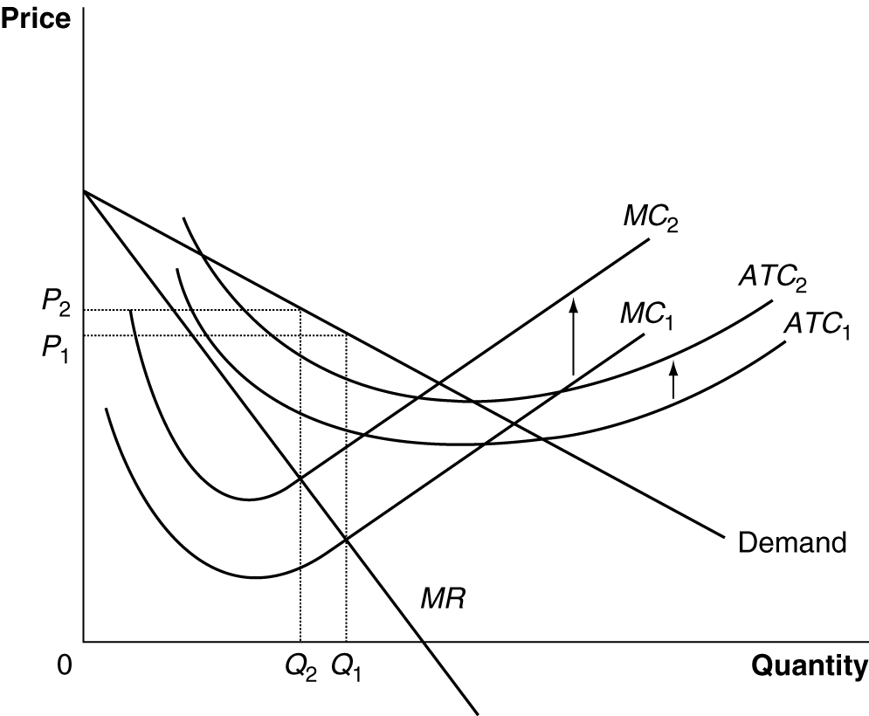

9. The analysis is incorrect. The student has forgotten that economic costs include a normal rate of return on the owners’ investment in the firm. Therefore, firms will not leave the industry when earning zero economic profit.

10. In this context, “making goods in large quantity” means making more than the profit-maximizing quantity – making so many that the marginal cost exceeds the marginal revenue. Producing too many Rolls-Royce automobiles might also ruin their reputation for exclusiveness and ultimately reduce the demand for them. This is not a problem with most products. On the other hand, building a large factory that exhibits diseconomies of scale would be a problem for any firm.

11a. The demand for ordering books online must be price elastic.

11b. P₁ is the non-profit-maximizing price Amazon was charging before the price cut. P₂ is the profit-maximizing price.

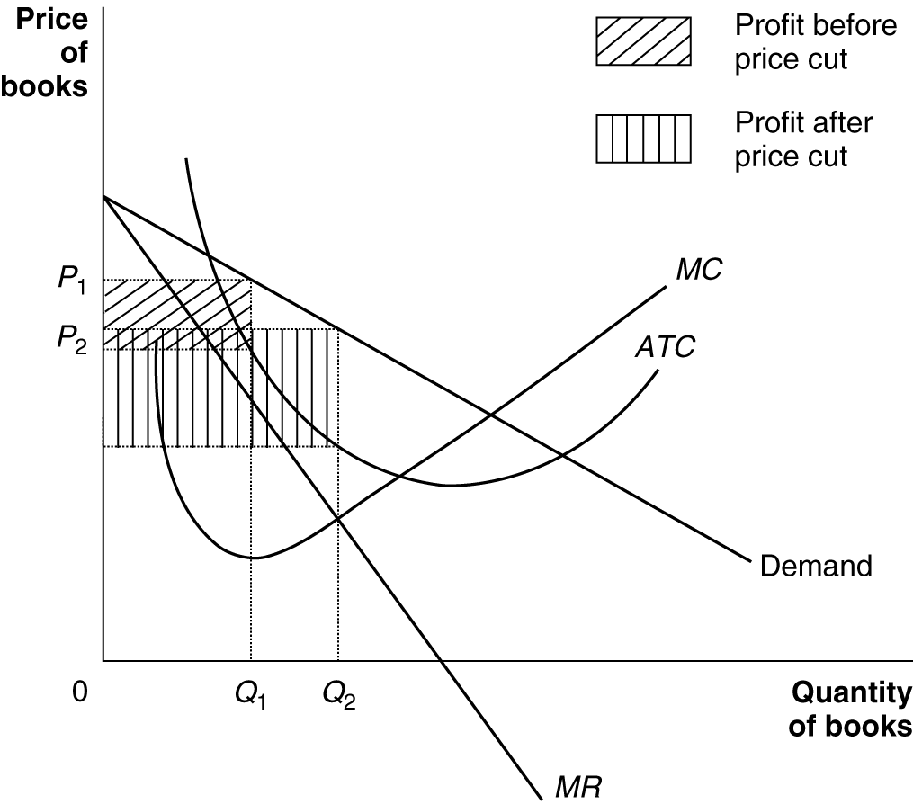

12. Competition in markets results in firms being forced to produce the goods most desired by consumers and keeps most firms from earning more than a normal rate of return in the long run.

13. Few will agree. Firms differentiate their products in order to appeal to consumers’ varied tastes. The success of product differentiation strategies indicates that many consumers find differentiated products preferable to the alternatives. Consumers are, therefore, better off than they would be if companies did not differentiate their products – they are willing to pay for the higher costs (“waste”) caused by differentiation.

14. Consumers gain from the lower prices productivity gains make possible. The firms are not more profitable because competition causes the prices they charge to fall to the level of the average total costs.

15a. Drexler’s strategy will increase J. Crew’s costs, but if it is successful it will also increase demand by enough to increase the company’s profits.

15b. The strategy may be successful in raising J.Crew’s profits in the short run. But barriers to entry in the clothing industry are low, so in the long run there is nothing preventing other companies from copying J. Crew’s strategy, which would leave the company earning zero economic profit.

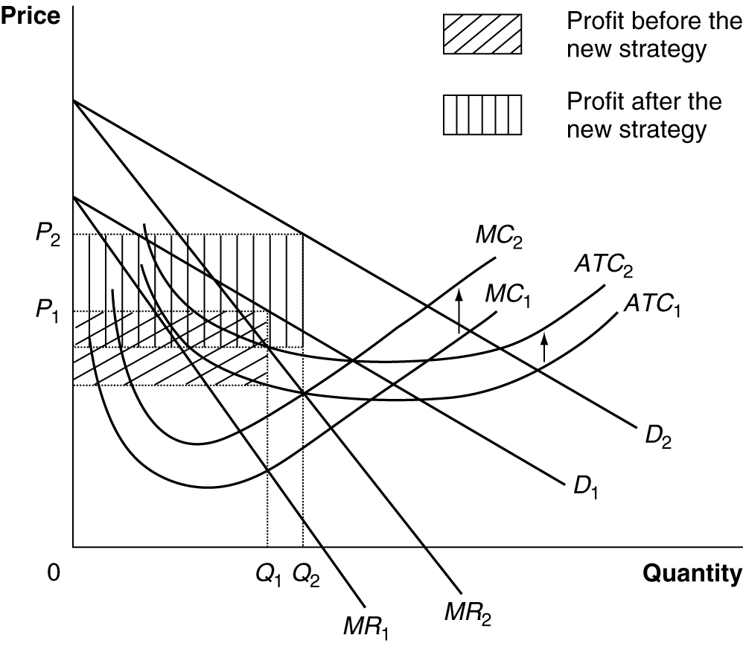

16. Competition is a risk because it can reduce a firm’s profits. The barriers to entry are low in retailing, so the competition is intense.

17a. Initial revenue = $440 x 500,000 = $220,000,000. Revenue after price cut: $360 x 800,000 = $288,000,000. So, he expected total revenue to rise.

17b. Recall that the midpoint formula uses the average of the initial and final quantity and the initial and final price. The average of the initial and final prices of Model T’s is 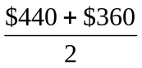 = $400 and the average of the initial and final quantities is 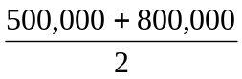 = 650,000. So, the percentage change in the quantity demanded = 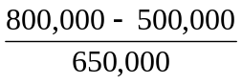 x 100 = 46.2% and the percentage change in the price =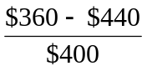 x 100 = -20%. So, the price elasticity of demand for Model T’s = 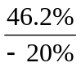 = -2.3.

17c. Profit = Revenue – Cost. $60,000,000 = $288,000,000 – (ATC x 800,000); therefore, to earn a profit of $60,000,000, the ATC for making 800,000 cars must be $285. ATC for 500,000 Model T’s: Total Cost = Revenue – Profit = $220,000,000 – $60,000,000 = $160,000,000. Therefore, ATC = $160,000,000/500,000 = $320. So the ATC of producing 800,000 Model T’s was lower than the ATC of producing 500,000 Model T’s.

17d. Yes. If the profit is the same and he is selling more cars, he must be making a smaller profit per car. We can check this by calculating the profit per car (price minus ATC): For 500,000 cars, profit per car = $440 – $320 = $120 per car; for 800,000 cars, profit per car = $360 – $285 = $75 per car.

18. It will be very difficult to become rich by following the advice found in a book, because if the book really has a good idea, then a lot of people will follow its advice. In the process, they will compete away the profits from following the advice. Only those who pounce on the profit opportunity quickly will earn great profits before imitators enter the market and eliminate the profits. (In addition, if the author’s advice is really that valuable, he or she will probably want to keep it secret, using it in his or her own business rather than telling rivals about it.)

19. Advertising is a fixed cost, so it will shift up the ATC curve, but not the MC curve.

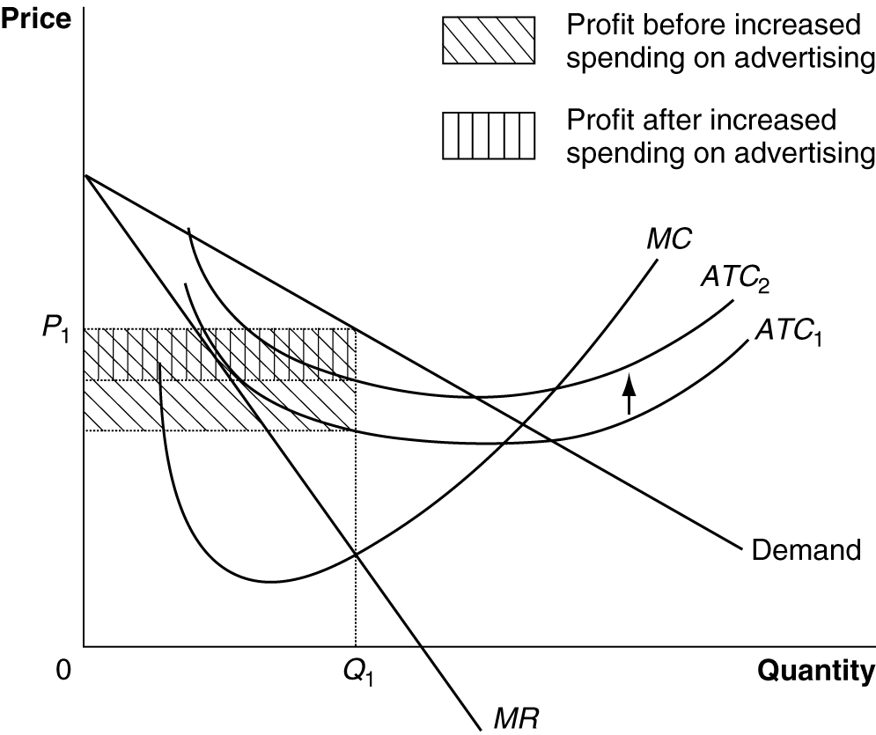

20. This is a good way to find out what customers want, but it probably isn’t a good way to make a profit because other firms already know this same information and are selling products to these customers. Entering the market with products exactly like the competition will only work if your firm somehow has lower costs than the other firms. On the other hand, firms who discover new information about what customers want can temporarily make a profit supplying it until new firms enter the market and competition drives profits back to zero.

21. Once a firm’s image is tarnished, it can be very expensive to improve the situation. Advertising and law suits may help, but they can be very expensive. Another famous example of a product image mishap is Reebok’s Incubus running shoes for women. Reebok was surprised to learn that in medieval legend an incubus was a male demon who preyed on sleeping women. After a big frenzy in the press, Reebok changed the shoe line’s name.

22. The skeptics who think that “Starbucks’ game is almost over” think that other firms will soon be copying Starbucks so well that the demand for Starbucks’ products will shrink and it won’t be able to earn high economic profits any more.

